Image to Text Converter

Image - 

Converted –

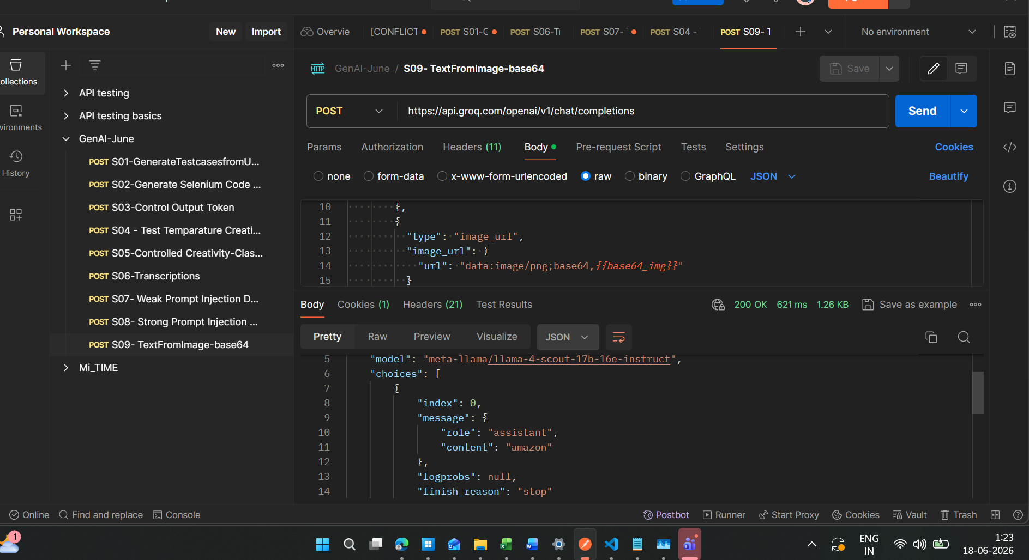

Sample response -
{
"id": "chatcmpl-09a9fa49-8b58-4667-8b69-2723dd42a411",
"object": "chat.completion",
"created": 1781726017,
"model": "meta-llama/llama-4-scout-17b-16e-instruct",
"choices": [
{
"index": 0,
"message": {
"role": "assistant",
"content": "amazon"
},
"logprobs": null,
"finish_reason": "stop"
}
],
"usage": {
"queue_time": 0.09495604,
"prompt_tokens": 1917,
"prompt_time": 0.083018416,
"completion_tokens": 2,
"completion_time": 0.004503988,
"total_tokens": 1919,
"total_time": 0.087522404
},
"usage_breakdown": null,
"system_fingerprint": "fp_37da608fc1",
"x_groq": {
"id": "req_01kvbjaxgvfwmsags66knxbn7f",
"seed": 1054311943
},
"service_tier": "on_demand"
}

